**Exercise no 1**

**Instructions:**

**Please read the following instructions carefully before submitting this Hands-on Exercise:**

1. **Use Microsoft Word to prepare exercise solution.**
2. **Your submitted exercise will not be considered/counted if:**
3. **It is submitted after due date.**
4. **It does not open, or file is corrupt.**
5. **It is copied (partial or full) from any source (websites, forums, groups, students, etc.)**
6. **It must be a pdf document at time of submission. Document in given formates (.doc or .docx) are not Accepted**

**Learning Outcomes:**

**After completing this exercise, you shall be able to:**

* **Understand The using of Widgets in Footer**
* **Understand how to install Plugins & Themes from WordPress Directory**
* **Create Your Post and understand the use of making Widgets in Website Footer**

**Reminder:**

**Understand the Problem statement and Compelete the given task**

**Problem Statement:**

As you know Themes and Plugins are necessary to make Website in a WordPress. As Theme display display the Apperance of your website as how its look in user window. On the other Plugins add Additional Functionality in your WordPress Website

**Tips for the problem Solution’s:**

**For Theme**

A good Theme must be a good one that Compatible with your WordPress Version.

**For Plugin**

Plugin is also tested with your wordpress Version. Bcz Its necessary for the proper functioning

**For Widget**

Widget is important because. They make your site interactive and good looking specially to create a good footer its necessary to understand the importance of Widgets and Their usage. A good theme makes for you a good widget**.**

**Tasks:**

* Install and Activate a Theme in your Website Through WordPress Directory
* Install and Activate a Plugin in your website Through WordPress Directory
* Create a blog post as required Content
* Try to make a good footer using widget like given in image below

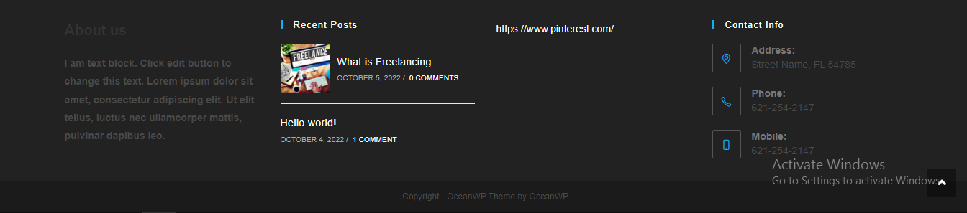

**Note:**

**If you already have an installed plugin or theme DO NOT Activate another account**

**Requirements:**

1. **Screenshot(ss) of your installed and Activated plugin and Theme from WordPress Directory in WordPress dashboard.**
2. **Screenshot(ss) of your ever created Good looking blog post in your installed theme using block editor.**
3. **Screenshot(ss) of your WordPress created Widgets (Trying to make a sam as i mentioned in screenshot).**

**Guidelines:**

* **If you find to install a Theme Difficult then install “Asta” Theme in WordPress directory as it may make your work effiecient**
* **You can install “Contact form 7” plugin as it is easy to install and Activate if you find Difficult to install a plugin**
* **If you find to make a widget as i shown in image so hectic then dont be worry you can make a good footer as you wants. But if you make that in scene told me the reason otherwise its get rejected.**

**Note:**

**If you have any queries related to the Hands-on Exercise, then you can contact me via Wattsapp Group**

**Good Luck Developers**